Noise DISCIPLINE REPORT
Project Name
SR #
MILEPOST XX.XX to Xx.xx

Prepared By:
name
WAshington State Department of Transportation
Air, Noise, and Energy Program
15700 Dayton Ave, North
PO Box 330310
Seattle, WA 98133-9710

DATE
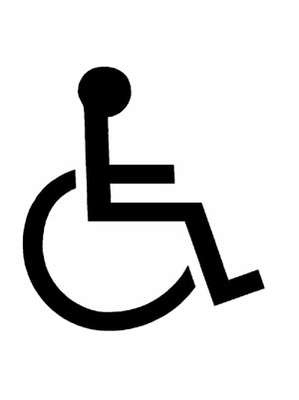

Title VI
It is the Washington State Department of Transportation’s (WSDOT) policy to assure that no person shall, on the grounds of race, color, national origin or sex, as provided by Title VI of the Civil Rights Act of 1964, be excluded from participation in, be denied the benefits of, or be otherwise discriminated against under any of its federally funded programs and activities. Any person who believes his/her Title VI protection has been violated, may file a complaint with WSDOT’s Office of Equal Opportunity (OEO). For additional information regarding Title VI complaint procedures and/or information regarding our non-discrimination obligations, please contact OEO’s Title VI Coordinator at (360) 705-7090.

Americans with Disabilities Act (ADA) Information
This material can be made available in an alternate format by emailing the Office of Equal Opportunity at wsdotada@wsdot.wa.gov or by calling toll free, 855-362-4ADA (4232). Persons who are deaf or hard of hearing may make a request by calling the Washington State Relay at 711.
If more explanations of the exhibits and graphics are needed. Please feel free to contact the Air Quality, Noise, and Energy group at oppfela@wsdot.wa.gov or check out our webpage at Noise | WSDOT (wa.gov).

table of contents
SECTION 1 SUMMARY 1-1
Purpose 1-1
Existing Noise Environment 1-1
Noise Impacts of the Project 1-1
Considered Abatement 1-2
SECTION 2 PROJECT DESCRIPTION 2-1
Project Elements Overview 2-1
Type 1 Trigger for Noise Analysis 2-1
SECTION 3 CHARACTERISTICS OF NOISE 3-1
SECTION 4 METHODOLOGY 4-1
Noise Study Area 4-1
Traffic Noise Measurements and Validation Model 4-1
SECTION 5 PROJECT EFFECTS 5-1
Traffic Noise Analysis 5-1
Traffic Noise Abatement 5-5
Feasibility 5-5
Reasonableness 5-5
Cost Effectiveness 5-6
Design Goal Achievement 5-7
Residential Equivalency 5-8
Noise Wall Analysis 5-8
Recommendation for Traffic Noise Abatement 5-12
SECTION 6 CONSTRUCTION NOISE EFFECTS 6-1
Construction Noise Variance for Night Work 6-2
Construction Noise Abatement 6-2
Conclusion 6-3
SECTION 7 REFERENCES 7-1

Exhibits
Exhibit 1-1 Noise Impacts and Abatement at Modeled Locations 1-2
Exhibit 2-1 SR # / Project Name Vicinity Map 2-2
Exhibit 2-2 SR # / Project Name Build Alternative(s) 2-3
Exhibit 3-1 Typical Noise Levels 3-2
Exhibit 3-2 FHWA Noise Abatement Criteria by Land Use 3-5
Exhibit 3-3 Maximum Permissible Environmental Noise Levels 3-6
Exhibit 4-1 Noise Model Validation Results 4-2
Exhibit 4-2 Noise Measurement Locations 4-3
Exhibit 5-1 Existing, No-Build Alternative, and Build Alternative Noise Model Results 5-3
Exhibit 5-2 Noise Model Results 5-4
Exhibit 5-3 Reasonableness Allowances for Noise Walls 5-7
Exhibit 5-4 Feasibility Analysis for Noise Wall 5-9
Exhibit 5-5 Reasonableness Evaluation for Noise Wall 5-10
Exhibit 5-6 Proposed/ Evaluated Noise Wall(s) 5-11
Exhibit 6-1 Construction Equipment Noise Levels 6-2
Exhibit B-1 Modeled Hourly Traffic Volumes for Existing, Future No Build Alternative, and Build Alternative B-1
Exhibit B-2 Calculated Truck Percentages for Existing, Future No Build Alternative, and Build Alternative B-1
Exhibit C-1 WSDOT Established Usage Factors C-1
Exhibit C-2 Project Residential Equivalency C-1

Appendices
APPENDIX A TRAFFIC NOISE ANALYSIS AND ABATEMENT PROCESS A-1
APPENDIX B Traffic Data B-1
APPENDIX C RESIDENTIAL EQUIVALENCY C-1
APPENDIX D Field Notes D-1
APPENDIX E TNM Output E-1
ACRONYMS AND ABBREVIATIONS
Acronym | Meaning
ADA | Americans with Disabilities Act
ANE | Air, Noise, and Energy (Program)
dB | Decibels
dBA | A-weighted decibel
EDNA | Environmental designation for noise abatement
EPA | Environmental Protection Agency
FHWA | Federal Highway Administration
Ft² | square foot
Hz | hertz
LAeq | equivalent A-weighted sound level
LAeq(h) | equivalent A-weighted sound level averaged hourly
Lmax | maximum sound level during a period of time
Lmin | minimum sound level during a period of time
Ln | n representing the percentage of time the sound level exceeded
MP | Milepost
NAC | Noise Abatement Criteria
RE | residential equivalency
SEL | Sound exposure level
SR | State Route
TNM | traffic noise model
WAC | Washington Administrative Code
WSDOT | Washington State Department of Transportation

SUMMARY

Purpose
This report was prepared for the SR #/ Project Name (milepost [MP] XX.XX to XX.XX).
Provide a brief summary of the project including project details and purpose, jurisdiction vicinity, and action triggering Type 1 Study.
HIGHLIGHTED – project specific to be changed throughout the report
RED – notes and suggestions.

Existing Noise Environment
Provide a description of existing nearby land uses and the existing noise environment.

Noise Impacts of the Project
The analysis of noise impacts in the noise study area that would result from the Project is based on future sound levels compared to the existing levels and applicable criteria. Construction noise impacts are based on the maximum noise levels of construction equipment published by the Federal Highway Administration (FHWA, 2006) (Exhibit 6-1).
Washington State Department of Transportation (WSDOT) used the FHWA Noise Abatement Criteria (NAC) to evaluate traffic noise impacts (Exhibit 3-2). Traffic noise levels are predicted at sensitive receivers based on projected future traffic operations using the FHWA Traffic Noise Model (TNM) Version 2.5. Abatement measures that may be taken to avoid or reduce potential noise impacts are discussed where appropriate.
WSDOT evaluated the noise study area for the presence of receptors (homes, outdoor use areas, schools, etc.) sensitive to traffic noise. Noise study area does not have to be at 500 ft, just to capture the impact zone. We suggest the area should be based on the distance to the 65dBA contour. # receivers were modeled to determine current and future noise levels under the Existing and No-Build Alternative. Then compared the predicted future Build peak-hour noise levels to FHWA's NAC to determine if the Project will result in traffic noise impacts.
WSDOT compared the predicted peak-hour noise levels to the FHWA NAC to determine if there would be noise impacts with the Project. A substantial increase of 10 A-weighted decibels (dBA) or more in noise levels compared with the existing noise environment is also considered a noise impact. Listed below are existing year (YEAR), and future design year (YEAR) noise levels with and without the Project.
- Existing (YEAR) noise levels in the overall study area are between … dBA
- In YEAR, noise levels without the Project range between # and # and are predicted to … increase/decrease # dBA
- In YEAR, noise levels with the Project range between # and # and are predicted to … increase/decrease # dBA

Considered Abatement
WSDOT evaluated # noise walls along the right-of-way for feasibility (a combination of acoustic and engineering considerations that evaluates if abatement can be constructed that achieves a meaningful reduction in noise levels) and reasonableness (assesses the practicality of the abatement measure based on a number of factors after abatement is found to be feasible) to protect potentially affected homes and other sensitive receivers such as trails along the study area.
Exhibit 1-1 summarizes the existing and predicted noise conditions at the modeled locations.
Exhibit 1-1 Noise Impacts and Abatement at Modeled Locations
Condition | Construction Impacts | Operational Impacts | Abatement Measures
Existing YEAR  (PM peak) |  |  | None
YEAR No-Build Alternative  (PM peak) |  |  | None
YEAR Build Alternative
(PM peak)

PROJECT DESCRIPTION
Project Description, usually provided by the project office but can be summarized to include only relevant design features.

Project Elements Overview
This SR #/ Project Name will make improvements as recommended by (reference report or agency) by making the following improvements:
- List project details
Exhibit 2-1 provides the Project location.
Exhibit 2-2 provides the proposed Project.

Type 1 Trigger for Noise Analysis
A traffic noise analysis is required by law (23 Code of Federal Regulations [CFR] 772) for federally funded projects and required by WSDOT policy (WSDOT 2020) for other funded projects that meet the following criteria:
- Involve construction of a new highway on a new alignment.
- Significantly change the horizontal or vertical alignment.
- Increase the number of through-traffic lanes on an existing highway.
- Alter terrain to create new line-of-sight to traffic for noise-sensitive receivers.
Description of Type 1 activity on this project.

Exhibit 2-1 SR # / Project Name Vicinity Map

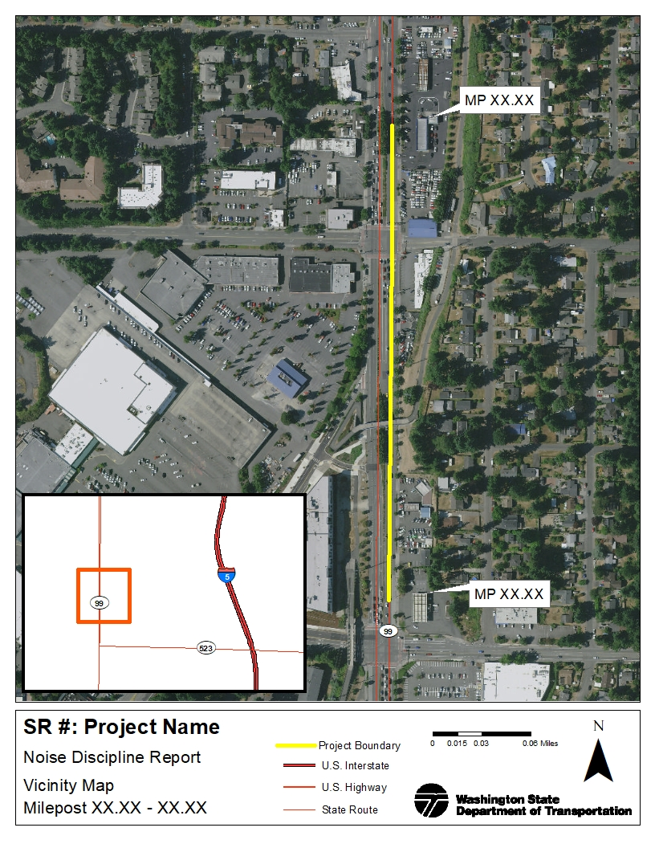
Exhibit 2-2 SR # / Project Name Build Alternative(s)

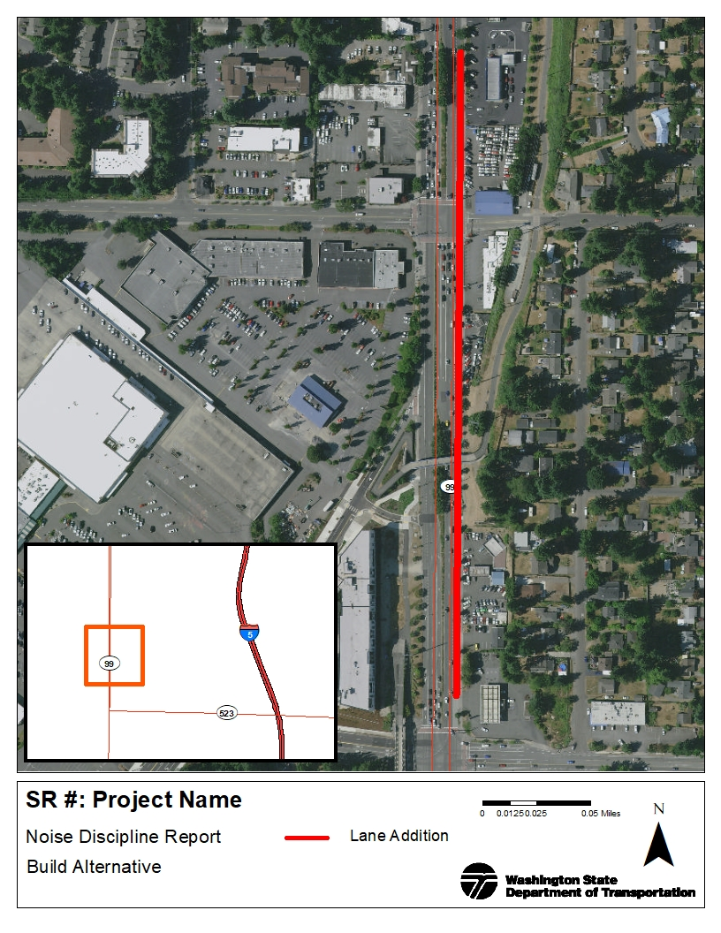

CHARACTERISTICS OF NOISE

Definition of Sound
Sound is created when objects vibrate, resulting in a minute variation in surrounding atmospheric pressure, called sound pressure. The human response to sound depends on the magnitude of a sound as a function of its frequency and time pattern (EPA 1974). Magnitude is a measure of the physical sound energy in the air. The range of magnitude the ear can hear, from the faintest to the loudest sound, is so large that sound pressure is expressed on a logarithmic scale in units called decibels (dB). Loudness refers to how people subjectively judge a sound and how it varies between people.
Sound is measured using the logarithmic decibel scale, so that doubling the number of noise sources, such as the number of cars on a roadway, increases the sound level by three A-weighted decibels (dBA). Therefore, when you combine two sources emitting 60 dBA, the combined sound level is 63 dBA, not 120 dBA. The human ear can barely perceive a 3-dBA increase, while a 5-dBA increase is about 1.5 times as loud and readily noticed. A 10-dBA increase appears to be a doubling in noise level to most listeners. A tenfold increase in the number of noise sources will add 10 dBA.
In addition to magnitude, humans also respond to a sound's frequency or pitch. The human ear is very effective at perceiving frequencies between 1,000 and 5,000 hertz (Hz), with less efficiency outside this range. Environmental noise is composed of many frequencies. A-weighting (dBA) of sound levels is a filter applied electronically by a sound-level meter that combines the many frequencies into one sound level that simulates how an average person hears sounds.

Definition of Noise
Noise is unwanted or unpleasant sound. Noise is a subjective term because, as described above, sound levels are perceived differently by different people. Exhibit 3-1 presents the magnitudes of typical noise levels.

Traffic Noise Sources
An increase in traffic volumes, vehicle speeds, or the number of heavy trucks increases traffic noise levels. Traffic noise is a combination of noises from the engine, exhaust, and tires. Defective mufflers, truck compression braking on steep grades, the terrain and vegetation near the roadway, shielding by barriers and buildings, and the distance from the road can also contribute to minimizing the traffic noise heard from traffic on roadway.

Exhibit 3-1 Typical Noise Levels
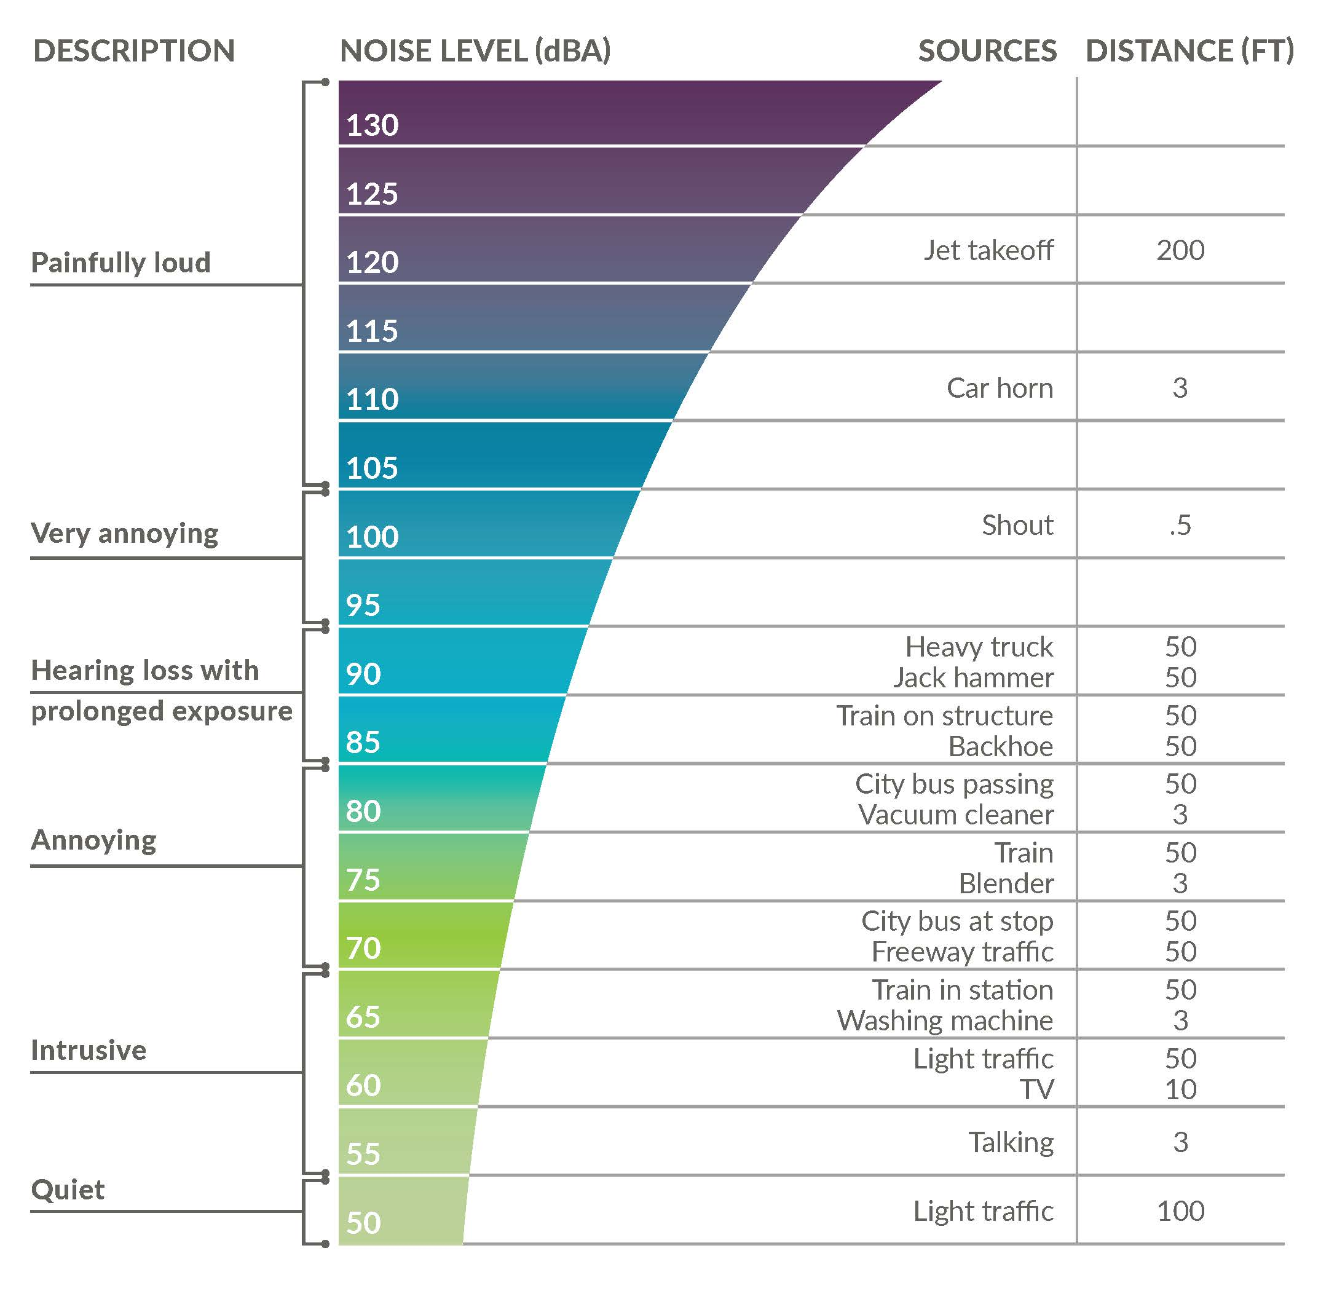
Source: FTA 1995

Sound Propagation
Sound propagation, or how far the sound travels, is affected by the terrain and the elevation of the receiver relative to the noise source. Breaking the line of sight between the receiver and the noise source can reduce noise levels. Listed below are examples of sound propagation pathways.

Level ground – Noise travels in a straight path between the source and receiver.
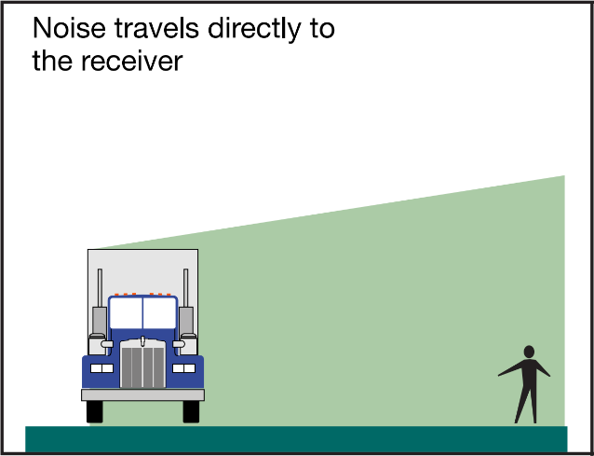
- Depressed source/elevated receiver – Terrain may act like a partial noise barrier and reduce noise levels if it crests between the source and receiver.
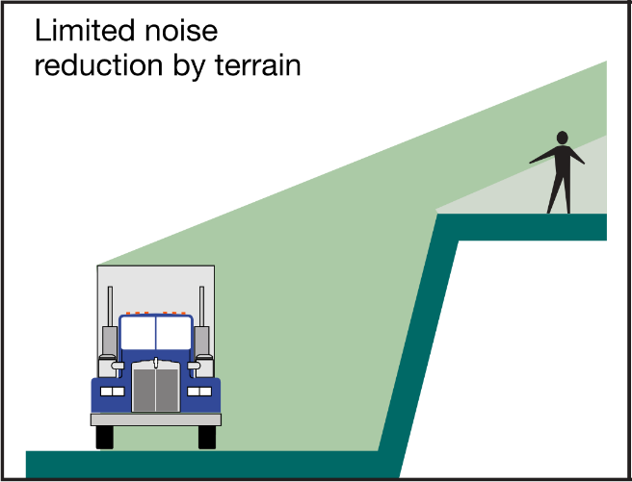
- Elevated source/depressed receiver – The edge of the roadway may act as a partial noise barrier. Even a short barrier, like a concrete safety barrier, can reduce the noise level.
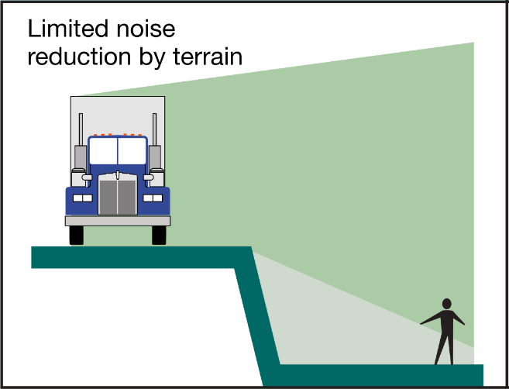

Line and Point Sources
Noise levels decrease with distance from the source. For a line source, like a highway, noise levels decrease 3 dBA for every doubling of distance, e.g., from 66 dB at 50 feet to 63 dB at 100 feet, between the source and the receiver over hard ground (concrete, pavement), or 4.5 dBA over soft ground (grass). For point sources, like most construction noise, the levels decrease between 6 and 7.5 dBA for every doubling of distance, depending on ground hardness.

Effects of Noise
The FHWA NAC are based on speech interference, which is a well-documented impact that is relatively reproducible in human response studies. Environmental noise indirectly affects human welfare by interfering with sleep, thought, and conversation. Prolonged exposure to very high levels of environmental noise can cause hearing loss, and the U.S. Environmental Protection Agency (EPA) has established a protective level 70 dBA equivalent sound level (LAeq) (24) for hearing loss (EPA 1974).

Noise Level Descriptors
The Leq is a measure of the average noise level during a specified period of time. A 1-hour period, or hourly Leq [Leq (h)], is used to measure highway noise. Leq is a measure of total noise during a time period that places more emphasis on occasional high noise levels that accompany general background noise levels. For example, if you have two different sounds, and one contains twice as much energy but lasts only half as long as the other, the two would have the same Leq noise levels.
Either the total noise energy or the highest instantaneous noise level can describe short-term noise levels, such as those from a single truck passing by. The sound exposure level (SEL) is a measure of total sound energy from an event and is useful in determining what the Leq would be over a period in time when several noise events occur. Lmax is the maximum sound level that occurs during a single event and is related to impacts on speech interference and sleep disruption. Lmin is the minimum sound level during a period of time.
The variation of sound levels recorded during a measurement period is represented by L_{n}, where “n” is the percent of time that a sound level is exceeded. For example, the L₁₀ level is the noise level that is exceeded 10 percent of the time. Sound varies in the environment and people will generally find a higher, but constant, sound level more tolerable than a quiet background level interrupted by higher sound level events. For example, steady traffic noise from a highway is normally less bothersome than occasional aircraft flyovers in an otherwise quiet area.

Noise Regulations and Impact Criteria
Traffic noise impacts occur when predicted LAeq (h) noise levels approach or exceed the NAC established by the FHWA, or substantially exceed existing noise levels (USDOT 2021). WSDOT considers a noise impact to occur if predicted LAeq (h) noise levels approach within 1 dBA of the NAC. Exhibit 3-2 describes exterior LAeq(h) noise levels for various land activity categories specified by the NAC. WSDOT also considers an increase of 10 dBA or more to be a substantial increase and constitute a traffic noise impact. See Appendix B, Traffic Noise Analysis and Abatement Process, for a detailed description of the noise analysis and abatement process.
Activity Category A is a designation for an area where quiet would be considered extraordinary, it serves an important public need and where preservation of these qualities is essential for this area to continue to serve in this manner. If an area is to be considered as a Category A approval must be granted by FHWA headquarters in Washington D.C prior to the start of the noise study. As of this writing, there are no Category A lands in Washington state.
Exhibit 3-2 FHWA Noise Abatement Criteria by Land Use
Activity  Category | Leq(h) at Evaluation Location  (dBA) | Description of Activity Category
A | 57 (exterior) | Lands on which serenity and quiet are of extraordinary significance and serve an important public need and where the preservation of those qualities is essential if the area is to continue to serve its intended purpose. For example, Arlington National Cemetery.
B | 67 (exterior) | Residential (single- and multi-family units).
C | 67 (exterior) | Active sport areas, amphitheaters, auditoriums, campgrounds, cemeteries, daycare centers, hospitals, libraries, medical facilities, parks, picnic areas, places of worship, playgrounds, public meeting rooms, public or nonprofit institutional structures, radio studios, recording studios, recreation areas, Section 4(f) sites, schools, television studios, trails, and trail crossings.
D | 52 (interior) | Auditoriums, daycare centers, hospitals, libraries, medical facilities, places of worship, public meeting rooms, public or nonprofit institutional structures, radio studios, recording studios, schools, and television studios.
E | 72 (exterior) | Hotels, motels, offices, restaurants/bars, and other developed lands, properties or activities not included in A–D or F. Includes undeveloped land permitted for these activities.
F | - | Agriculture, airports, bus yards, emergency services, industrial, logging, maintenance facilities, manufacturing, mining, rail yards, retail facilities, shipyards, utilities (water resources, water treatment, electrical), and warehousing.
G | - | Undeveloped lands that are not permitted.
Leq(h) are A-weighted (dBA) hourly equivalent steady state sound levels used for impact determination and are not design standards for abatement.

Construction Noise Levels Limits
Traffic and construction noise are exempt from the Washington Administrative Code (WAC) property line noise limits during daytime hours, but noise limits still apply to construction noise at night. Noise levels shown in Exhibit 3-3 apply only to construction noise at residential properties between 10 p.m. and 7 a.m. At night, construction noise must meet Washington State Department of Ecology property line regulations (WAC 173-60-040) that set limits based on the Environmental Designation for Noise Abatement (EDNA) of the land use: residential (Class A), commercial (Class B), and industrial (Class C).
Allowable nighttime (10 p.m. to 7 a.m.) noise levels at Class A receiving properties (residential) are reduced by 10 dBA (WAC 173-60).
Exhibit 3-3 Maximum Permissible Environmental Noise Levels
EDNA of Noise Source | EDNA of Receiving Property (dBA)
 | Class A | Class B | Class C
Class A | 55 | 57 | 60
Class B | 57 | 60 | 65
Class C | 60 | 65 | 70

Short-term exceedance of the sound levels in Exhibit 3-3 is allowed. During any 1-hour period, the maximum level may be exceeded by the following:
- 5 dBA for a total of 15 minutes
- 10 dBA for a total of 5 minutes
- 15 dBA for a total of 1.5 minutes (WAC 173-60-040)
The allowed exceptions are defined by the percentage of time a given level is exceeded. For example, L₂₅ is the noise level exceeded 15 minutes during an hour. Therefore, the permissible L₂₅ would be 5 dBA greater than the values in Exhibit 3-3, provided that the noise level is below the permissible level for the rest of the hour and never exceeds the permissible level by more than 5 dBA.

METHODOLOGY

Noise Study Area
Provide a land use description.
Provide a Noise Study Area description, the methods, and assumptions used to determine the distance from the edge of the nearest travel lane to the outer edge of the noise study area.
This noise study analyzed # receivers within # feet of the edge of the pavement on both sides of SR # throughout the project corridor.

Traffic Noise Measurements and Validation Model
Traffic sound levels were measured to describe the existing noise environment, identify other potential major noise sources in the study area, and validate the noise model.
The Acoustics Specialist collected #-minute LAeq measurements at locations representative of sound-level environments in the study area during free-flowing traffic conditions. (Describe the length of the noise measurement taken and why) FHWA allows 15-minute LAeq measurements to represent the hourly LAeq (h). These traffic noise measurements are not a representation of average existing noise levels.
To ensure that the noise model used to predict traffic noise impacts accurately reflects the sound levels in the noise study area, the Acoustics Specialist constructed a model using the same traffic volumes, speed, and vehicle types that were present during the sound level measurements. Modeled values must be within ±2.0 dBA of the measured levels to validate the model.
The FHWA TNM Version # (YEAR) was used for validation and to predict future LAeq (h) traffic noise levels. TNM calculates precise estimates of noise levels at discrete points. The model estimates the sound levels from a series of straight-line roadway segments. TNM also considers the effects of existing noise barriers, buildings, topography, vegetation, temperature, and atmospheric absorption. Noise from sources other than traffic is not accounted for in the model. When non-traffic noise is present, such as aircraft noise, TNM will under-predict the actual noise level. To ensure the model does not under-predict, noise measurements are paused to avoid interference of other noise sources. To create the model TNM 2.5 - design files outlining major roadways, topographical features, and sensitive receivers were imported into the TNM model as background features and the corresponding values were entered manually. We used aerial photographs and site visits to verify site conditions.
Exhibit 4-1 lists the measurement locations and the comparison of measured to modeled values for the validation of the model. The analysis included noise measurements taken at # sites chosen to represent noise-sensitive sites in the study area. The measured sites represented … describe the types of noise sensitive sites and/or Activity Categories where measurements were collected. For noise model validation, we entered traffic volumes in the noise model to match field counts during the time of day of the noise measurement.
The noise levels at the # measured sites were modeled using TNM. All # sites were within ±2 dBA (no rounding as per WSDOT 2020) of the measured values. The # validated locations indicate that the model accurately represented site conditions.
Exhibit 4-1 Noise Model Validation Results
Site # | Measured Receiver Location | Date | Start Time | Measured  L_{eq} (dBA) | Modeled  L_{eq} (dBA) | Difference (dBA)

Exhibit 4-2 shows the measured receivers’ locations. In this exhibit, measured receivers are denoted by the letter V followed by a number

Exhibit 4-2 Noise Measurement Locations
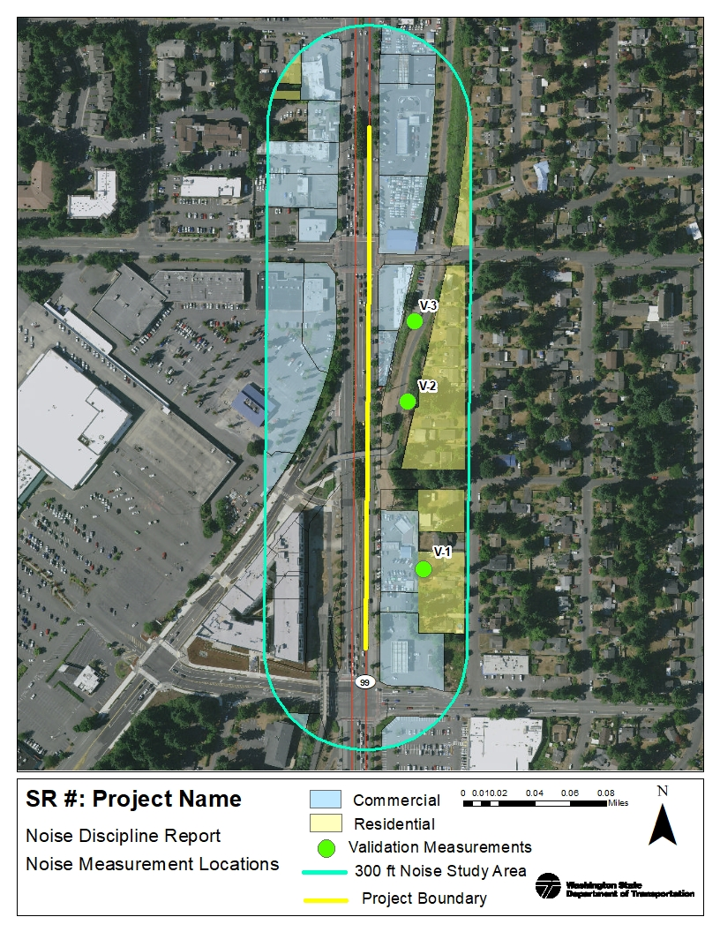

PROJECT EFFECTS

Traffic Noise Analysis
FHWA requirements and WSDOT policy dictate that noise studies assess properties adjacent to highway projects that could be potentially affected by traffic noise. Primary consideration must be given to areas of frequent outdoor human use, such as residences with yards, decks, or patios. Parks and schools with outdoor play areas also warrant primary consideration of potential noise impacts. This section presents results of noise modeling for current and future traffic noise levels in the study area.
The Acoustics Specialist assessed the study area for the types of land uses noted above, at or above the traffic noise impact levels, in the following conditions. We evaluated # receivers representing # list type of receivers (residences, trails, commercial, schools, churches, etc.). Of the # receivers evaluated, the following were determined to be at or above traffic noise impact levels:
- Existing conditions (YEAR) traffic noise impacts …
- No-Build Alternative (YEAR) traffic noise impacts …
- Build Alternative (YEAR) traffic noise impacts …
The Acoustics Specialist input existing peak-hour traffic data into the TNM model. The TNM noise model predicted loudest-hour noise levels using the peak hour traffic volumes for the existing and future traffic conditions. Additional receivers were added to the TNM model to represent receivers.
Existing, No-Build Alternative, and Build Alternative traffic noise levels for all modeled receivers in the study area are presented in Exhibit 5-1. Build traffic noise levels above and below the NAC are depicted in Exhibit 5-2. The location of the additional modeled sites are labeled with numbers preceded by the letter R (or M). Receivers modeled on floors above the ground level should be followed by the letters a, b, c, and so on to represent the different floors. The traffic volumes and vehicle mix for the Project are documented in Appendix B, Traffic Noise Analysis and Abatement Process.

Existing Noise Level (YEAR)
We modeled existing traffic volumes for YEAR and the results are in Exhibit 5-1. The Existing noise model included # receivers to provide detailed noise level information throughout the noise study area. The modeling results show …

Design Year Traffic Noise Level – No-Build Alternative (YEAR)
No-Build Alternative traffic noise levels are provided in Exhibit 5-1 and are projected to increase/decrease by # dBA over existing conditions. This increase/decrease over existing conditions is a result of projected increases in traffic volumes in the design year of YEAR without the Project. The modeling results show …

Design Year Traffic Noise Level – Build Alternative (YEAR)
With the Project, YEAR noise levels are projected to increase/decrease by # dBA over existing noise levels and increase/decrease by # dBA over No-Build noise levels at the modeled locations. The modeling results show that # receivers representing type of noise sensitive receivers as in the Existing and No-Build models to be at or above the noise impact level under the YEAR Build Alternative. Also consider Build modeled receivers that are 10 dB or greater above existing noise levels as noise impacts. All properties projected to approach or exceed the impact level or are 10 dB or greater above existing noise levels under the Build Alternative are analyzed for noise abatement.

Exhibit 5-1 Existing, No-Build Alternative, and Build Alternative Noise Model Results
Receiver # | Receiver Type | Receiver Category | Residential Equivalency | Existing (YEAR) L_{eq} (dBA) | No-Build Alternative (YEAR) L_{eq} (dBA) | Build Alternative (YEAR) L_{eq} (dBA) | Build vs Existing  (dB) | Build vs No-Build (dB)
Bold numbers represent noise levels at or above WSDOT impact levels.

Exhibit 5-2 Noise Model Results

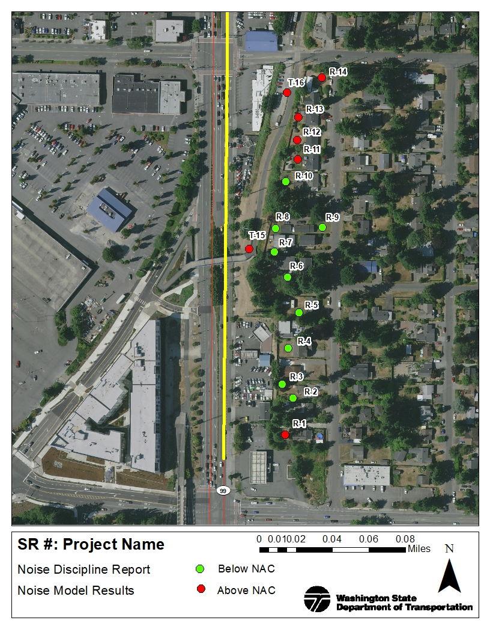

Traffic Noise Abatement
Noise abatement is considered only where there is (1) a modeled noise level of 66 dBA or higher in the design year Build Alternative, (2) an increase of 10 dBA over existing conditions for land use categories A, B, C, and D as defined in Exhibit 2-2, or (3) 71 dBA or higher for land use Category E. If such a situation exists, abatement is considered only where frequent human use occurs and where a lower noise level would have benefits. Noise levels can be reduced by the following types of abatement.
- Traffic management, such as restrictions on the types of vehicles and the time they may use a certain roadway.
- Change in vertical or horizontal alignment of the roadway.
- Acquisition of property.
- Construction of noise barriers, such as noise walls.
FHWA requires, at a minimum, to consider noise abatement in the form of a noise wall (23 CFR 772.13(c)(1)). While the other abatement strategies listed are an option, they are often not practical and so are not required to be evaluated if you meet the minimum requirement.
Abatement was considered for the traffic noise impacts related to the Project. Some of the modeled noise levels approach or exceed FHWA NAC levels. We evaluated increases between the Existing and Build Alternative.
Noise abatement must be both feasible and reasonable for it to be recommended for construction.

Feasibility
Feasibility is a combination of acoustic and engineering considerations. WSDOT evaluates many factors to determine whether noise walls would be feasible. All of the following must occur for abatement (e.g., noise barrier) to be considered feasible (WSDOT 2020):
- Abatement must be physically constructible.
- A minimum of three (3) first row impacted receivers must obtain a minimum 5 dBA of noise reduction as a result of abatement (insertion loss), assuring that every reasonable effort will be made to assess outdoor use areas as appropriate.

Reasonableness
When noise abatement is determined feasible, we assess whether the abatement is reasonable. WSDOT would only construct noise walls, or other types of abatement, if the noise walls have been determined reasonable after thoroughly evaluating the criteria below (WSDOT, 2020).
The reasonableness criteria of a noise barrier depends on the noise level at the noise sensitive receivers that would benefit from the barrier. To be reasonable, the proposed wall must be cost-effective and it must also meet the design goal for noise reduction. The noise barrier area may not exceed the sum of the total allowed area per household, which is converted to cost per household using our current statewide average cost per square foot of $51.61/ sq. ft., for all households that would benefit by at least 5 dBA, and 7 dBA at one location, as a result of the barrier. The allowed area per household is a function of the predicted future noise level during the loudest hour. For receivers that represent outdoor use areas other than single-family residences, WSDOT calculates a residential equivalency (RE) see Appendix C.

Cost Effectiveness
The cost of noise abatement sufficient to provide at least the minimum feasible noise reductions must be equal to or less than the allowable cost of abatement for each noise wall location analyzed. Based on noise wall costs from 2010 to 2015, the current average cost in Washington is $51.61 per square foot. The cost is applied to the allowed wall surface area (square feet) to generate the allowable cost per benefitted resident, as described in Exhibit 5-3.
Either wall square footage or cost can be used to evaluate cost effectiveness, unless costs for the wall will exceed the cost of a standard design noise wall; then cost must be used to compare the wall cost to the allowable cost.
For the Project, we evaluated a standard noise wall design, and the cost associated with the noise wall is used to describe the cost effectiveness. The allowable cost per receiver, based on Build Alternative traffic noise levels, is presented in Exhibits 5-4 and 5-5.

Exhibit 5-3 Reasonableness Allowances for Noise Walls
Design Year Traffic Sound Decibel Level (dBA) | Noise Level Increase Because of a Transportation Project (dBA)ª | Allowed Wall Surface Area per Qualified Residence or Residential Equivalent (square feet) | Allowed Cost per Qualified Residence or Residential Equivalent ^{b}
66 |  | 700 | $36,127
67 |  | 768 | $39,636
68 |  | 836 | $43,146
69 |  | 904 | $46,655
70 |  | 972 | $50,165
71 | 10 (substantial, step 1)^{c} | 1,040 | $53,674
72 | 11 (substantial, step 1) | 1,108 | $57,184
73 | 12 (substantial, step 1) | 1,176 | $60,693
74 | 13 (substantial, step 1) | 1,244 | $64,203
75 | 14 (substantial, step 1) | 1,312 | $67,712
76 | 15 (substantial, step 2)^{d} | 1,380 | $71,222
ª If the noise level increases 10 dBA or more as the result of a project (Column B), follow the allowed wall surface and cost for the level of increase in Columns C and D, respectively, in lieu of the total design year sound decibel level in Column A. For total highway-related sound levels at 76 or more dBA or if the project results in an increase of 15 or more decibels, continue increasing the allowance at the rate provided herein unless circumstances determined on a case-by-case basis require a methodology for determining the allowance.
^{b} Current costs are based on $51.61 per square foot constructed cost developed in 2020.
^{c} Step 1 – when the noise levels are 10 to 14 dBA over future No Build Alternative traffic noise as a result of a transportation project.
^{d} Step 2 – when the noise levels are 15 or more dBA over existing traffic noise because of the transportation project (or total highway-related noise levels are between 76 and 79 decibels). Additional consideration for abatement may be considered under these circumstances.

Design Goal Achievement
The design goal for abatement on all transportation projects for reasonableness is at least 7 dBA of reduction for at least one noise sensitive receiver. Noise walls cannot be recommended if they do not achieve the design goal. In addition to the design goal requirement, WSDOT makes a reasonable effort to get 10 dBA or greater insertion loss (noise reduction) at the first row of receivers for all projects where abatement is recommended.
The following reasonableness evaluation exhibit in this report describes the allowable cost per receiver and the cost of the minimum barrier size to achieve the design goal.

Residential Equivalency
For noise-sensitive users other than residences, we calculate a residential equivalency (RE) of these facilities users based on the usage factor and number of users, according to WSDOT’s Traffic Noise Policy and Procedures (WSDOT, 2020). Residences are assumed to be in use at all times, but many other facilities such as schools have specific hours of operation. The usage factor accounts for the times of operation (Appendix C, Residential Equivalency, shows typical usage factors). In Washington, the average household has three members, so for sites with other than residential uses, the number of users is multiplied by a usage factor and divided by three to convert to equivalent households. Appendix C, Residential Equivalency, presents the residential equivalency for receivers in the noise study area that include sensitive uses (other than single-family residences) that approached or exceeded the NAC.

Noise Wall Analysis
WSDOT evaluated noise barriers at # different locations where noise levels were predicted to approach or to exceed the NAC to determine whether abatement could sufficiently reduce traffic noise levels. One of the evaluated noise walls were deemed to be both feasible and reasonable. The following section summarizes noise wall feasibility, reasonableness, and, if applicable, the size of the recommended barrier.
List areas and walls that were evaluated. We suggest naming the walls by numbering and including directional prefixes to indicate how it is directionally located with respect to the highway (e.g. Noise Wall 1, Noise Wall East 2, etc.)

Noise Wall (Feasible, Not Reasonable/ Reasonable)
We evaluated a noise wall describe wall dimensions, location and any unique characteristics (e.g., is it an overlapping wall). Per WSDOT’s feasibility requirement, there must be at least three impacted first-row receivers with 5 dB reduction or more.
Describe # and type of receivers, how the RE was calculated (if applicable), and dBA reduction achieved.
As shown in Exhibit 5-4 and 5-5, the Area is feasible/ not feasible. Describe dBA reduction achieved, how many impacted residents benefitted in the first row and benefitting residents beyond first row OR why it is not feasible.
Because the Area appears to be feasible and physically constructible, we also evaluated the wall for a reasonableness determination (see Exhibit 5-5). OR The Area was not found to be feasible because … explain why … OR Reasonableness was not evaluated for this project because a barrier could no achieve feasibility.

Exhibit 5-4 Feasibility Analysis for Noise Wall
Site | Number of Residences or RE’s | YEAR Build w/o Wall (LAeq) (dBA) | YEAR Build with Wall (LAeq) (dBA) | First-Row Receiver?  (Yes/No) | Insertion Loss (dBA) | Number of Receiver ≥5 dBA
R-#
R-#
R-#
R-#
R-#
R-#
R-#
R-#
R-#
R-#
R-#
Feasible? |  |  |  |  |  | Y/N
Bold numbers represent noise levels at or above WSDOT impact levels.

Describe how it meets WSDOT’s design goal: A noise wall of this size would achieve WSDOT’s design goal of reducing traffic noise levels by at least 7 dBA at one residence.
If it meets the design goal, describe how it does/ does not meet WSDOT’s reasonableness requirements. Therefore, Wall 1 does/ does not meet WSDOT’s reasonableness requirement and is/ is not recommended for construction. If there is sufficient allowance suggest modeling two or three walls of different heights in three separate reasonableness tables to see which one provides the justification to be recommended for construction.
Describe how the wall is highly cost effective (if applicable)
See Exhibit 5-6 for the location of the evaluated noise wall.

Exhibit 5-5 Reasonableness Evaluation for Noise Wall
Site | Residences or  Residential Equivalency (RE) | YEAR Build w/o Wall (L_{eq}) (dBA) | Reasonableness Allowance |  | Design Goal Noise Wall |  | -10 dBA  In First Row
 |  |  | Area  (ft²) | Total Allowable Wall Area (ft²) | Total Wall Area (ft²) | Insertion Loss (dBA) | Total  Cost | Insertion  Loss  (dBA)
R-#
R-#
R-#
R-#
R-#
R-#
R-#
R-#
R-#
R-#
Reasonable? |  |  |  |  |  | Y/N | Y/N

Exhibit 5-6 Proposed/ Evaluated Noise Wall(s)

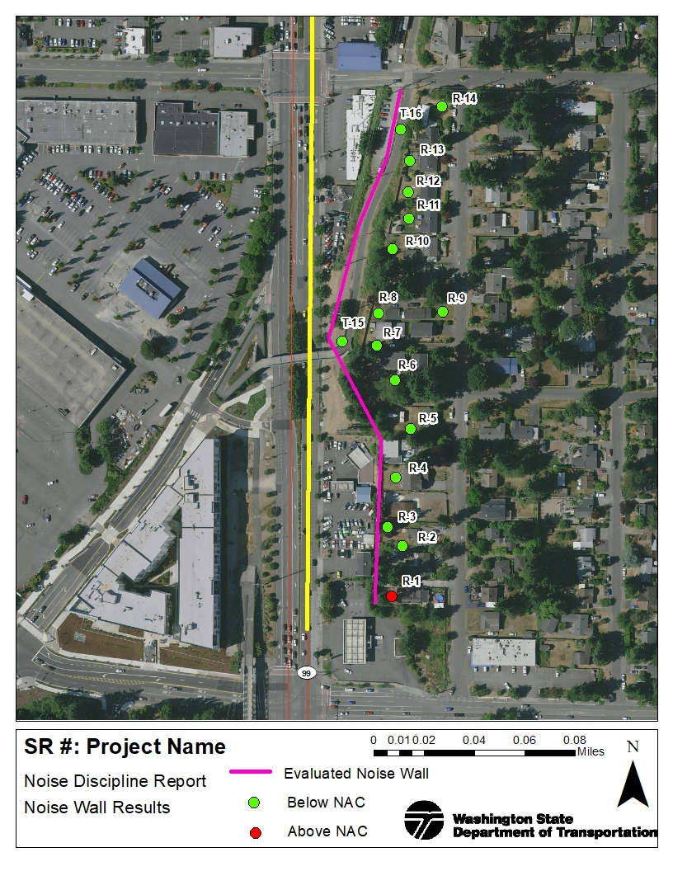

Recommendation for Traffic Noise Abatement
Describe which wall(s) were found to be both feasible and reasonable using WSDOT noise abatement criteria and is recommended for construction.
As discussed in Appendix B, if noise abatement is recommended, public outreach to determine public desires for abatement must occur. The noise wall discussion may be introduced to the public before the Design Phase, but should happen after the noise wall alignment, height, and length (or other abatement description) is established so that people can understand any impacts of the noise wall (or other abatement) on their community. Public outreach can be in different formats and depend on the size, controversy, and impact to the community (WSDOT, 2020). If opposition to the proposed abatement is expressed by the community this should be documented and a poll of the views of the community should be conducted to determine their desire for the wall. The final determination whether to construct a noise wall or other abatement that traffic noise analysis recommends cannot be made until public outreach has occurred.

CONSTRUCTION NOISE EFFECTS
Construction creates temporary noise and is usually carried out in reasonably discrete steps, each with its own mix of equipment and noise characteristics. For example, roadway construction typically involves demolition, construction, and paving.
The most constant noise source at construction sites is usually engine noise. Mobile equipment generally operates intermittently or in cycles of operation, while stationary equipment, such as generators and compressors, generally operates at fairly constant sound levels. Trucks are present during most phases of construction and are not confined to the project site, so noise from trucks may affect more receivers than other construction noise. Other common noise sources typically include impact equipment, which could be pneumatic, hydraulic, or electric-powered.
As noted in the list below, noise levels during the construction period depend on the type, amount, and location of construction activities.
- The type of construction methods establishes the maximum noise levels.
- The amount of construction activity establishes how often certain construction noises occur throughout the day.
- The location of construction equipment relative to adjacent properties determines the effect of distance in reducing construction noise levels.
The maximum noise levels of construction equipment are expected to be similar to the maximum construction equipment noise levels presented in Exhibit 6-1 and typically range from 69 to 106 dBA at 50 feet. As a point source, construction noise decreases by 6 dBA per doubling of distance from the source moving away from the equipment. The various pieces of equipment are almost never operating simultaneously at full power, and some would be powered off, idling, or operating at less than full power at any time. Therefore, the average Leq noise levels would be less than the sum of the maximum noise levels in Exhibit 6-1.
Exhibit 6-1 Construction Equipment Noise Levels
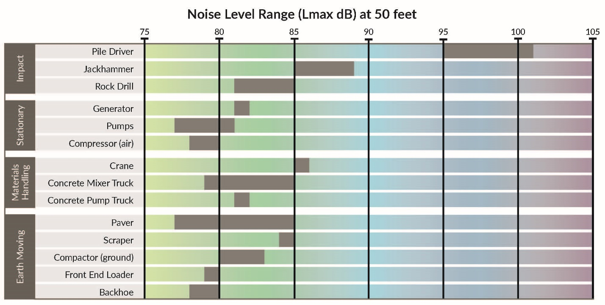

Construction Noise Variance for Night Work
Construction noise is exempt from state and local property line regulations during daytime hours. If nighttime construction is required for the Project, WSDOT would apply for variances or exemptions from local noise ordinances for the night work. Such noise variances or exemptions require construction noise abatement measures that vary by jurisdiction. If night work is mandated for the Project, WSDOT would obtain noise variances from the local jurisdictions.

Construction Noise Abatement
To reduce construction noise at nearby receptors, the following measures could be incorporated, where practicable, into construction plans and specifications:
- As construction is taking place in a specific area, if possible, WSDOT will construct proposed noise walls and barriers before other construction activities.
- WSDOT could equip construction equipment engines with mufflers, intake silencers, and engine enclosures, as appropriate.
- WSDOT could turn off construction equipment during prolonged periods of nonuse to reduce noise.
- WSDOT could locate stationary equipment away from receiving properties to decrease noise.
- WSDOT could maintain all equipment and train their equipment operators in good practices to reduce noise levels.
- WSDOT could use Occupational Safety and Health Act-approved ambient sound-sensing backup alarms that could reduce disturbances from backup alarms during quieter periods.

Conclusion
Wrap up results, concluding thoughts, or recommendations.

REFERENCES
Federal Highway Administration (FHWA). 2010. Directive "Highway Traffic Noise: Analysis and Abatement.” U.S. Department of Transportation. Washington, D.C. Revised in December.
Federal Transit Administration (FTA), U.S. Department of Transportation. 1995. Transit Noise and Vibration Impact Assessment. Washington D.C.
U.S. Environmental Protection Agency (EPA). 1971. Noise from Construction Equipment and Operations, Building Equipment, and Home Appliances. Washington, D.C. NTID 300.1. December 31, 1971. Revised WSDOT District 1, February 1991.
U.S. Environmental Protection Agency (EPA). 1974. Information on Levels of Environmental Noise Requisite to Protect Public Health and Welfare with an Adequate Margin of Safety. Report Number 550/9-74-004.
Washington Administrative Code, 1989. Chapter 173-60. Maximum Environmental Noise Levels. Olympia, Washington.
Washington State Department of Transportation (WSDOT). 1987. Directive D22-22, Noise Evaluation Procedures for Existing Highways. Olympia, Washington.
Washington State Department of Transportation (WSDOT). 1991. Revised construction equipment noise ranges from Bolt et al. (1971).
Washington State Department of Transportation (WSDOT). 2020 Traffic Noise Policy and Procedures. Olympia, Washington. March 2020.

TRAFFIC NOISE ANALYSIS AND ABATEMENT PROCESS
When are noise reports and/or recommendations final?
The noise abatement process, from preparation of a noise wall to the final noise wall design (or decision not to build), can be confusing. The following process attempts to provide some clarification to project teams and outlines a recommended “standard” process but acknowledges that variations to this process are likely because of the differences between projects.
Environmental Discipline Reports
The noise analyst works with the project team to model project elements affecting noise that include traffic, topography, and the location of noise-sensitive receivers. If traffic noise impacts are discovered through modeling, then abatement is evaluated.
Abatement is compared to the feasibility (constructability, effectiveness) and reasonableness (allowable barrier size/cost) for a “standard” project. If abatement is feasible and reasonable, the report recommends the optimal (cost to benefit) noise barrier.
After completion of the above, the traffic noise discipline report can be finalized.
Design Phase
The Design Phase steps described below, and the Public Involvement steps described in the following section may be incorporated before the discipline report is finalized.
The project office reviews the recommended noise wall height and horizontal alignment to determine if there are any conflicts that were not realized when the discipline report was prepared.
If conflicts from utilities, steep slopes, etc. are present, the project team provides the details and costs of the conflicts to the noise analyst. The noise analyst will then add any additional (“but for” the noise wall) costs to the reasonableness evaluation. If noise wall costs, including accommodation of conflicts, are still less than the allowable costs for the noise wall, the barrier height and/or alignment are re-evaluated, and a new barrier will be recommended. If barrier costs plus the new costs exceed the allowable costs, the barrier may not be recommended by the WSDOT Air, Noise, and Energy (ANE) Program.
If a noise wall is recommended, the ANE Program will review and confirm noise wall dimensions throughout the design process.
Public Involvement
If noise abatement is recommended in the Traffic Noise Discipline Report, public outreach to determine public desires for abatement must occur. The noise wall discussion may be introduced to the public before the Design Phase, but should happen after the noise wall alignment, height, and length (or other abatement description) is established so that people can understand any impacts of the noise wall (or other abatement) on their community.
The final determination whether to construct a noise wall or other abatement that traffic noise analysis recommends cannot be made until public outreach has occurred.
Final Steps
Any updates to the Traffic Noise Discipline Report to clarify changes that occurred during the Design Phase or from Public Involvement can be made at the project engineering offices discretion. An addendum or supplementary memorandum to clarify changes can also be added to the discipline report or project file.
The noise wall is constructed or a letter from the ANE Program is added to the project file clarifying why a noise wall was not constructed.

Traffic Data
Exhibit B-1 Modeled Hourly Traffic Volumes for Existing, Future No Build Alternative, and Build Alternative
Segment | YEAR Existing Peak PM |  |  | YEAR No Build Alternative Peak PM |  |  | YEAR Build Peak PM
 | Eastbound | Westbound | Total | Eastbound | Westbound | Total | Eastbound | Westbound | Total

Exhibit B-2 Calculated Truck Percentages for Existing, Future No Build Alternative, and Build Alternative
Segment | Year | Passenger Vehicles |  |  | Medium Duty Trucks |  |  | Heavy Duty Trucks
 |  | Eastbound | Westbound |  | Eastbound | Westbound |  | Eastbound | Westbound
 |  | % |  | % | % |  | % | % |  | %
 |  | % |  | % | % |  | % | % |  | %
Note: Source

RESIDENTIAL EQUIVALENCY
WSDOT calculates reasonableness based on the number of residences that benefit from a noise wall. For noise-sensitive uses other than residences, a residential equivalency (RE) of the users is calculated, based on the usage factor and number of users (WSDOT, 1987). Residences may be in use at all times, but many other facilities such as schools have specific hours of operation. The usage factor accounts for the times of operation. Exhibit D-1 shows typical usage factors. In Washington, the average household has three members, so for sites use other than residential, the usage factor is multiplied by the number of users and then divided by three to convert to an equivalent number of households.
Exhibit C-1 WSDOT Established Usage Factors
Site | Hours/Day | Days/Week | Months/Year | Usage Factor
Hospital | 24 | 7 | 12 | 1
Place of Worship | 6 | 3 | 12 | 0.11
School | 10 | 5 | 9 | 0.22
Park | 10 | 7 | 5 | 0.17

Explain how the number of users were estimated for each (show calculations).
Exhibit C-2 presents the residential equivalencies calculated for this report.

Exhibit C-2 Project Residential Equivalency
Noise  Receivers | Activity Description | Number of  Users | Usage  Factor | Users to  Households  Conversion Factor | Residential  Equivalency (RE)
R-#
R-#

Field Notes
Field notes and pictures

TNM Output
- Project Name_Validation
- Project Name_Exisiting
- Project Name_NoBuild
- Project Name_Build/Barrier Analysis

