Chapter 1350 Railroad Grade Crossings

1350.02 References

Federal/State Laws and Codes
Revised Code of Washington (RCW) 81.53, Railroad crossings
 http://apps.leg.wa.gov/rcw/default.aspx?cite=81.53
Washington Administrative Code (WAC) 480-62-150, Grade crossing petitions
 http://apps.leg.wa.gov/wac/default.aspx?cite=480-62-150

Design Guidance
Agreements Manual, M 22-99, WSDOT

https://wsdot.wa.gov/publications/manuals/M22-99
Manual on Uniform Traffic Control Devices for Streets and Highways, USDOT, FHWA; as adopted and modified by Chapter 468-95 WAC “Manual on uniform traffic control devices for streets and highways” (MUTCD)
 www.wsdot.wa.gov/publications/manuals/mutcd.htm
Standard Plans for Road, Bridge, and Municipal Construction (Standard Plans), M 21-01, WSDOT
 www.wsdot.wa.gov/publications/manuals/m21-01.htm

Supporting Information
A Policy on Geometric Design of Highways and Streets (Green Book), AASHTO
Guidance On Traffic Control Devices At Highway-Rail Grade Crossings, Highway/Rail Grade Crossing Technical Working Group (TWG), FHWA, November 2002

https://safety.fhwa.dot.gov/hsip/xings/docs/guidance_on_traffic_control_devices.pdf

Railroad-Highway Grade Crossing Handbook—Third Edition, FHWA, 2019

https://safety.fhwa.dot.gov/hsip/xings/com_roaduser/fhwasa18040/
Manual on Uniform Traffic Control Devices Part 8. Traffic Control for Railroad and Light Rail Transit Grade Crossings
 http://mutcd.fhwa.dot.gov/htm/2009/part8/part8_toc.htm

1350.03 Plans

(1) Proposed Improvements
- Sight Distance
A railroad grade crossing is comparable to the intersection of two highways where a sight triangle is kept clear of obstructions (including vegetation) and may be protected by a traffic control device. When designing for these locations, provide for both corner and clearing sight distance.
Corner sight distance allows a driver traveling towards a crossing to see an approaching train at a distance that allows the vehicle to stop in advance of the crossing. (see Exhibit 1350-1, Case A.)
Clearing sight distance allows a driver stopped at a crossing to see far enough down the tracks that they may decide to proceed and cross those tracks before a train, approaching at its maximum allowable speed, reaches the crossing (see Exhibit 1350-1, Case B.)

For Cases A and B, the minimum distance for removing signs, brush and timber in the vicinity of the grade crossing that obstruct the view of an approaching train is 100 feet, measured along the tracks from the crossing.

Among the challenges associated with providing sight distance at railroad grade crossing locations are topography, seasonal crops or other vegetation, andstructures or other obstructions in properties that the sight lines cross, including the railroad. Evaluate, with the HQ Railroad Liaison, and document the need to install active control devices (such as signals or signals and gates) at locations where the distances in Exhibit 1350-1 cannot be provided or maintained over time. Contact the HQ Railroad Liaison to engage the subject railroad and the WUTC in the evaluation.

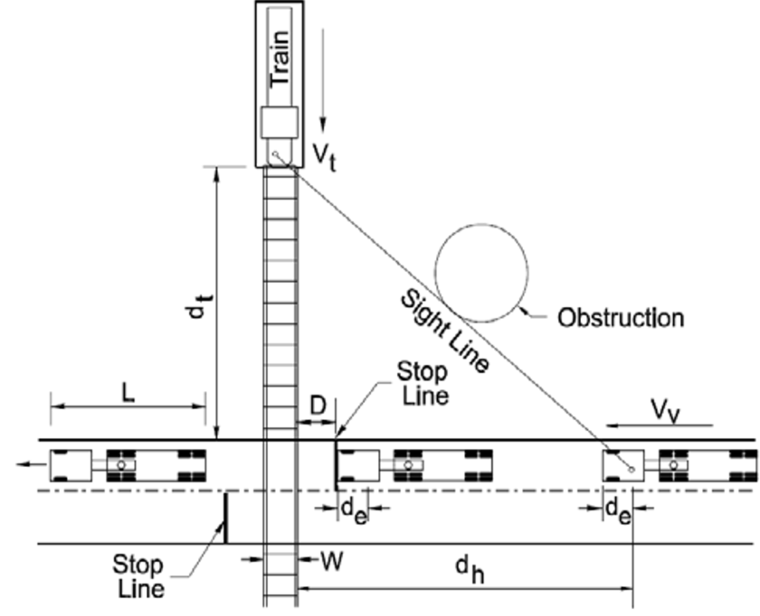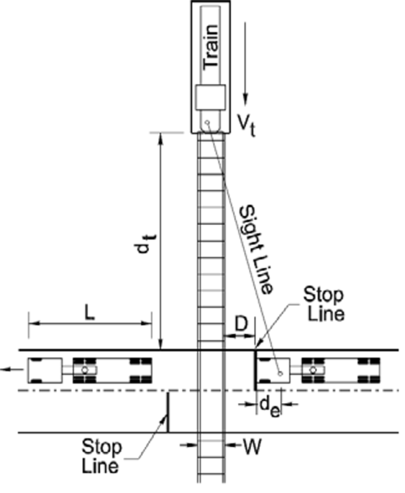
CASE A: Corner Sight Distance CASE B: Clearing Sight Distance
(Moving Vehicle) (Departure from Stop)

dh = Sight distance along highway (ft)
dt = Sight distance along railroad tracks (ft)
de = Distance from driver to front of vehicle (8 ft)
D = Distance from stop line to nearest rail (15 ft)

Notes:
- Adjust for skewed crossings.
- Assume flat highway grades adjacent to and at crossings.
W = Distance between outer rails (single track W=5 ft)
Vv = Velocity of vehicle (mph)
Vt = Velocity of train (mph)
L = Length of vehicle (73.5 ft)

Train Speed Vt (mph) | Case B: Departure From Stop  (Feet) [1] | Case A: Moving Vehicle
 |  | Vehicle Speed (mph) Vv
 | 0 | 10 | 20 | 30 | 40 | 50 | 60 | 70 | 80
 | Distance Along Railroad From Crossing dt (Feet) [1]
10 | 255 | 155 | 110 | 102 | 102 | 106 | 112 | 119 | 127
20 | 509 | 310 | 220 | 203 | 205 | 213 | 225 | 239 | 254
30 | 794 | 465 | 331 | 305 | 307 | 319 | 337 | 358 | 381
40 | 1,019 | 619 | 441 | 407 | 409 | 426 | 450 | 478 | 508
50 | 1,273 | 774 | 551 | 509 | 511 | 532 | 562 | 597 | 635
60 | 1,528 | 929 | 661 | 610 | 614 | 639 | 675 | 717 | 763
70 | 1,783 | 1,084 | 771 | 712 | 716 | 745 | 787 | 836 | 890
80 | 2,037 | 1,239 | 882 | 814 | 818 | 852 | 899 | 956 | 1,017
90 | 2,292 | 1,394 | 992 | 915 | 920 | 958 | 1,012 | 1,075 | 1,144
 |  | Distance Along Highway From Crossing d_{h} (ft)
 |  | 69 | 135 | 220 | 324 | 447 | 589 | 751 | 931
Design sight distance for a combination of highway and train vehicle speeds and a WB-67 (73.5-ft) truck crossing a single set of tracks at 90° (AASHTO).
Note: [1] Values shown in Case A and Case B are desirable. Refer to DM1350.03(1)(a) for the minimum value.

De=
Source: A Policy on Geometric Design of Highway and Streets, 2018, Table 9-29, page 9-167 by the American Association of State Highway and Transportation Officials.
Sight Distance at Railroad Crossing
Exhibit 1350-1

