*Reviewers,*

*These changes are small, so we have combined these Design Manual Chapters.*

*Keep in mind that in combining these sections into one file shows that the formatting is different for some chapters, but section numbers are precise. Do not worry about the formatting or the section numbers. We will fix all formatting and section numbers before we publish in September.*

*Please set your MS Word to “Review”, “All Markup” to see all track changes and comments. And do not worry if your changes/comments go into new pages. We will take care of it.*

*Please review the changes below as you would any other Design Manual review using MS Word’s Track Changes and please add a comment about each of your changes to help us understand why you are suggesting your changes.*

***Thank you*** *for helping us improve the Design Manual for users like yourself.*

***Reviewers,*** *This* ***first*** *change is about removing lights from overhead signs.*

***1020.03(1) Illumination***

The retroreflectivity of currently approved sign sheeting removes the need to provide illumination for sign installations.

Sign lights for existing illuminated overhead and ground-mounted signs can be de-energized and removed when the retroreflective sheeting is adequate for nighttime legibility, or the existing sign is replaced with a new sign (see Exhibit 1020-1 for sheeting requirements). A nighttime assessment of all nonilluminated overhead signs within the project limits is required (contact the Region Traffic Office). Replace all signs that have inadequate retroreflectivity). In situations where a nonhighway light source interferes with a sign’s legibility, consider relocating the sign.

Where a new overhead sign is being installed adjacent to an existing sign with sign lights, all other signs on the structure shall be replaced unless they meet current sheeting requirements (see Exhibit 1020-1). The existing sign lights shall then be de-energized by maintenance. On projects where there is additional electrical work, de-energized sign lights shall be removed.

Where overhead sign visibility is less than 800 feet due to intervening sight obstructions such as highway structures or roadside features, roadside illumination may be considered to supplement reduced retroreflectivity from headlights. Overhead signs located within an area of continuous highway illumination are considered sufficiently illuminated. Overhead sign lights shall not be used.

**Exhibit 1020-1 Reflective Sheeting Requirements for Overhead Signs**

* 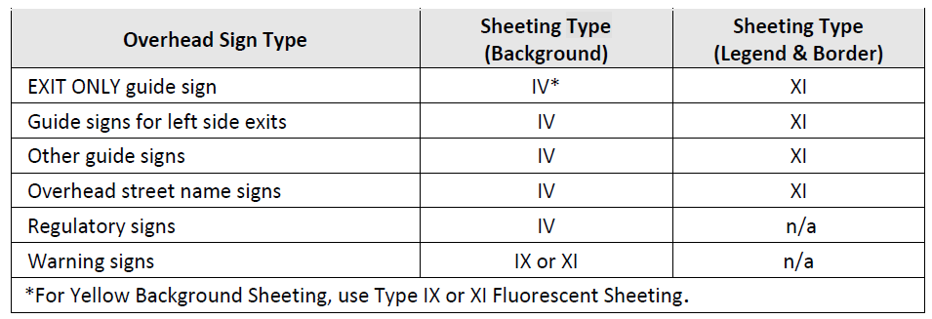

***Reviewers,***

*The point if this* ***second*** *set of changes is so Exhibits 1360-11a and 1360-11b match the striping shown on Standard Plan M-1.20-04 (shown below in the red box). Some Designers were drawing the striping based on Exhibits 1360-11a and 1360-11b instead of using Standard Plan M-1.20. So now they won’t be different.*

*Because these are graphic and not texts, if you have comments, we suggest that use Word’s Insert, Shapes tool. Or you can print it draw changes and scan your drawing. You can also, of course, add a word comment to the right side if the pictures.*

***Thank you*** *for helping us improve the Design Manual for users like yourself.*

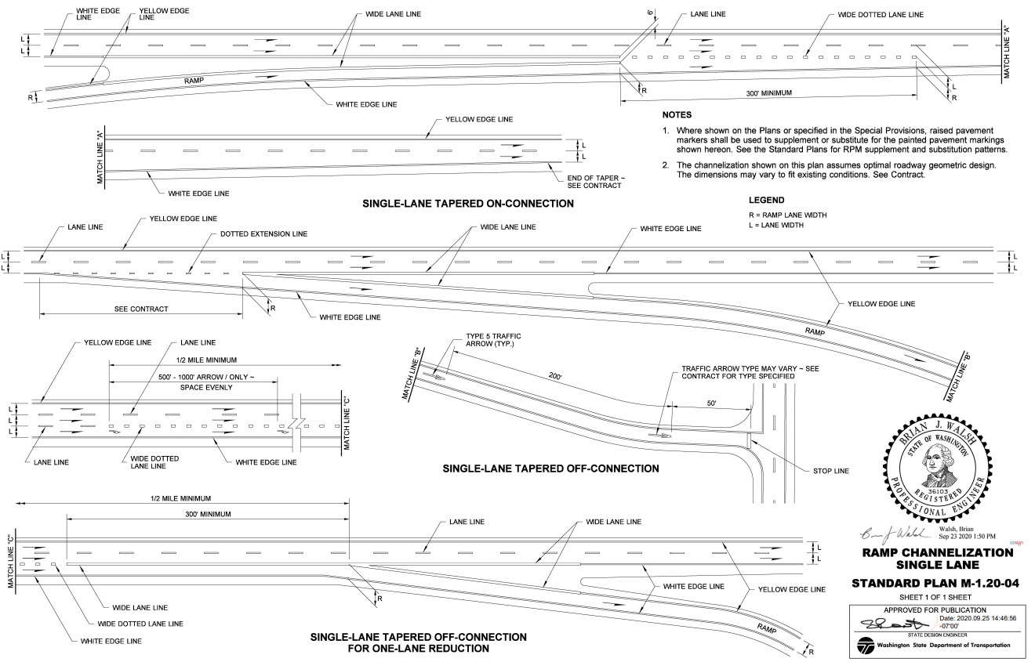

Chapter 1360 Interchanges

Exhibit 1360-11a Gore Area Characteristics

**Notes:**

1. The reserve area length (L) is not less than:

|  |  |  |  |  |  |  |  |  |
| --- | --- | --- | --- | --- | --- | --- | --- | --- |
| Main Line Design Speed (mph) | 40 | 45 | 50 | 55 | 60 | 65 | 70 | 80 |
| **L (ft)** | 25 | 30 | 35 | 40 | 45 | 50 | 55 | 70 |

1. , design speed is for the main line.
2. Radius may be reduced, when protected by an impact attenuator.

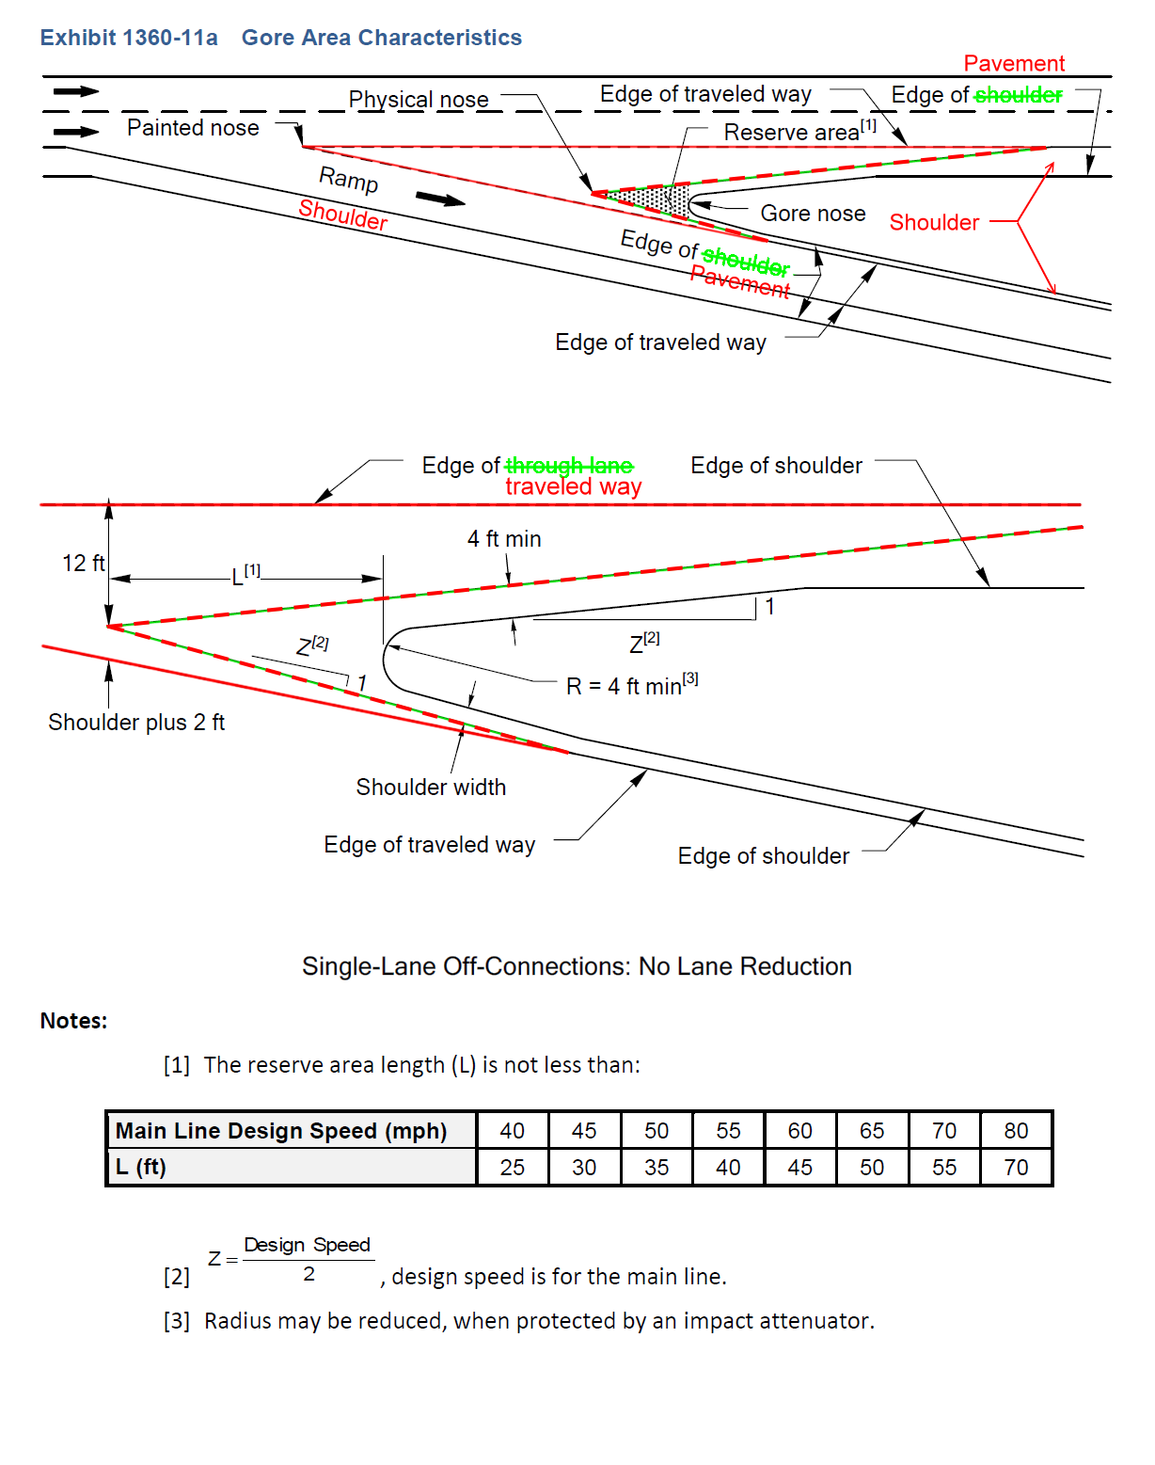

Exhibit 1360-11b Gore Area Characteristics



**Notes:**

1. The reserve area length (L) is not less than:

|  |  |  |  |  |  |  |  |  |
| --- | --- | --- | --- | --- | --- | --- | --- | --- |
| Main Line Design Speed (mph) | 40 | 45 | 50 | 55 | 60 | 65 | 70 | 80 |
| **L (ft)** | 25 | 30 | 35 | 40 | 45 | 50 | 55 | 70 |

1. , design speed is for the main line.
2. Radius may be reduced, when protected by an impact attenuator.

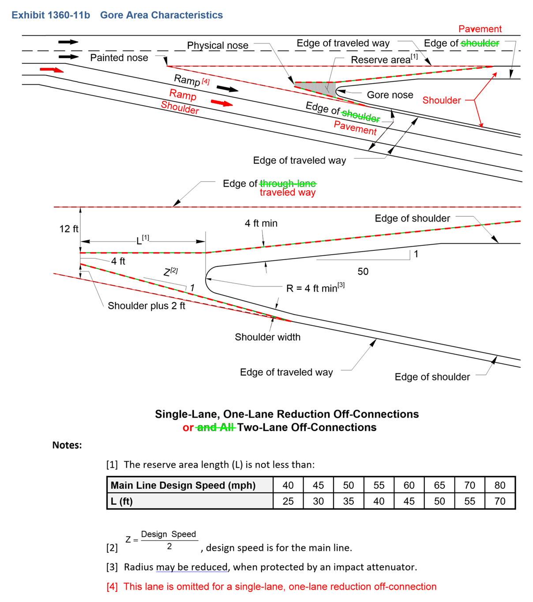

*Reviewers,*

*This* ***third*** *and* ***last*** *change is about adding HQ Traffic to the Public Art Specialty Services Team.*

Chapter 950 Public Art

# 950.05 Process and Project Delivery Timing

## 950.05(2) Public Art Specialty Services Team

Include the Public Art Specialty Services Team in the development of public art and the public art plan. The Team includes the following:

• Project Engineer or a designee (if the art is included in a project)

• State Bridge and Structures Architect

• Region or HQ Landscape Architect

• HQ Traffic Engineer

* Region Traffic Engineer

• Region Local Programs Engineer (if the proponent is a local community)

For public art proposed within Interstate Limited Access, the following team members are also required:

• Assistant State Design Engineer

• Federal Highway Administration (FHWA) Safety/Geometric Engineer or a designee

Consider team membership from the following functional areas when their expertise is applicable:

• Maintenance

• Planning

• Environmental

• Real Estate Services