GeoPortal User Guide
Author: Julie Jackson, WSDOT GIS and Roadway Data Office

Title VI Notice to Public
It is the Washington State Department of Transportation’s (WSDOT) policy to assure that no person shall, on the grounds of race, color, national origin or sex, as provided by Title VI of the Civil Rights Act of 1964, be excluded from participation in, be denied the benefits of, or be otherwise discriminated against under any of its programs and activities. Any person who believes his/her Title VI protection has been violated, may file a complaint with WSDOT’s Office of Equal Opportunity (OEO). For additional information regarding Title VI complaint procedures and/or information regarding our non-discrimination obligations, please contact OEO’s Title VI Coordinator at (360) 705-7090.
Americans with Disabilities Act (ADA) Information
This material can be made available in an alternate format by emailing the Office of Equal Opportunity at wsdotada@wsdot.wa.gov or by calling toll free, 855-362-4ADA (4232). Persons who are deaf or hard of hearing may make a request by calling the Washington State Relay at 711.
Notificación de Titulo VI al Público
Es la política del Departamento de Transporte del Estado de Washington el asegurarse que ninguna persona, por razones de raza, color, nación de origen o sexo, como es provisto en el Título VI del Acto de Derechos Civiles de 1964, ser excluido de la participación en, ser negado los beneficios de, o ser discriminado de otra manera bajo cualquiera de sus programas y actividades. Cualquier persona quien crea que su protección bajo el Titulo VI ha sido violada, puede presentar una queja con la Comisión Estadounidense Igualdad de Oportunidades en el Empleo. Para obtener información adicional sobre los procedimientos de queja bajo el Titulo VI y/o información sobre nuestras obligaciones antidiscriminatorias, pueden contactar al coordinador del Título VI en la Comisión Estadounidense de Igualdad de Oportunidades en el Empleo 360-705-7090.
Información del Acta Americans with Disabilities Act (ADA)
Este material es disponible en un formato alternativo enviando un email/correo electrónico a la Comisión Estadounidense de Igualdad de Oportunidades en el Empleo wsdotada@wsdot.wa.gov o llamando gratis al 855-362-4ADA (4232). Personas sordas o con discapacidad auditiva pueden solicitar llamando Washington State Relay al 711.

Table of Contents
Overview 3
Map display 4
Map tools 4
Map controls 5
Layers Tab 5
Legend Tab 6
Basemap Tab 7
Tools Tab 8
Map themes 10

Overview
The WSDOT GeoPortal is a browser-based map application that allows users to view spatial data, locate State Route milepost locations, and share base map information with others. This User Guide will help you get started using the GeoPortal to display data, use the tools in the GeoPortal, and share GeoPortal maps with others.
The application website is: https://www.wsdot.wa.gov/data/tools/geoportal/
This User Guide will cover the 4 main elements of the GeoPortal:
- Map Display
- Map Tools
- Map Controls
- Map Theme Selection
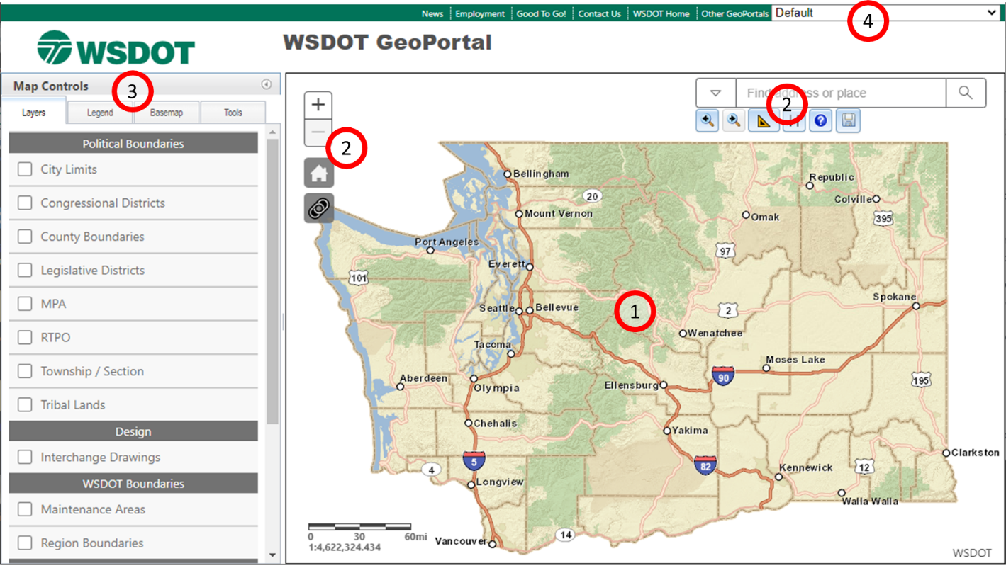

Map display
The map display area is where you will see selected map layers displayed. As you make map layer selections or zoom in or out the map display will automatically update with the selected data layers. A scale bar and reference scale in the lower left corner of the display will help you estimate distances on the map.
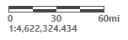
Map Navigation Shortcuts
You can zoom and pan the map in the following ways:
- Drag the mouse to pan.
- Mouse Scroll Forward to zoom in.
- Mouse Scroll Backward to zoom out.
- SHIFT + Drag the mouse to zoom in.
- SHIFT + CTRL + Drag the mouse to zoom out.
- SHIFT + Click to recenter.
- Double Click to Center and Zoom in.
- SHIFT + Double Click to Center and Zoom in.
- Use arrow keys to pan.
- Use + key to zoom in a level.
- Use - key to zoom out a level.
- Zoom in and out using the zoom +/- buttons on the left side of the map.
- Home Icon: will return the map to full screen.

Map tools
Map tools are located around the perimeter of the map display area.
Zoom in/zoom out
Zoom to statewide extent
Click to update URL with map layer and extent parameters (for sharing with others)
Zoom to previous extent
Zoom to next extent
Measure - Select the type of measurement ( area, length, coordinates) and the units of measurement (e.g. acres, square mile, or hectares for an area measurement). Once you select the measurement type and the units, click on the map to sketch the measurement. Quickly double click to finish your measurement sketch. The measurement result will appear in the measurement box in the units that you specified.
Arrange (re-order) layers – map layers are drawn in the order that they are listed on the Layers Tab (described below). The layer that is on top of the list draws on top of all of the layers below it. Use the Arrange tool to open a list of layers, then click on a layers and drag and drop it in a new location on the layer list. The layer you select will now be “re-ordered” in the drawing order.
Help (open the User Guide)
Export Graphics – Exports any map graphics that have been drawn on the Map Display to a GeoJson Feature Collection file.
Find address or place – click in the search box to type an address or location to zoom to. Click on the dropdown arrow to select a different type of search: Esri World Geocoder (provides the broadest search results), County (focuses on counties in Washington State), City (incorporated cities in Washington State), and Urban Area (… in Washington State).

Map controls
Map controls are located on the left side of the application.

Layers Tab
Click on the Layers Tab to activate the tab.
Check on the box next to a map layer to make it visible in the map display.
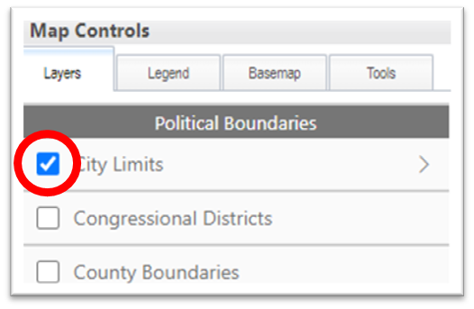
Once you have the box checked, you will see a newly activated layer options arrow on the right side of the window. Inside the Layer options window, you can: turn on/off sublayers, view the layers legend, adjust the layer’s opacity (transparency), and read the layer metadata (information about how the dataset was developed).
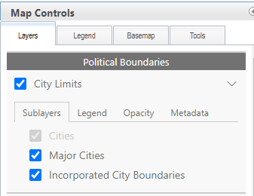

Legend Tab
When activated, the Legend tab displays the symbology for all active (visible) layers in the map view.
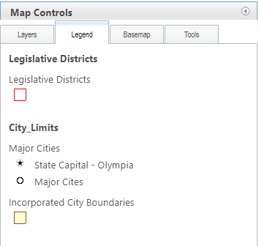

Basemap Tab
You can change the basemap displayed in the Map View by clicking on the Basemap Tab and clicking on a new basemap. For the most accurate representation of the Washington State Highway System, use the WSDOT Basemap.
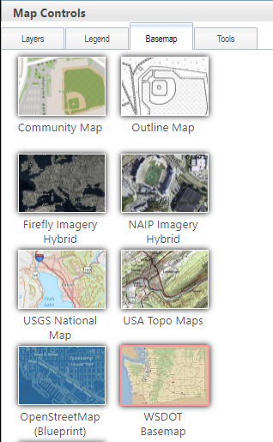

Tools Tab
There are four tools in the Tools Tab: Find Route Location/Find Nearest Route Location, Zoom To, Buffer and Draw.
Find Route Location and Find Nearest Route Location
- Find Route Location - type in a route number an ARM or SRMP, and a reference date, and then click on the Find Milepost button. The GeoPortal will place a graphic dot and a callout text box at the location that you specify. If the GeoPortal is unable to find your location it will return an error message. 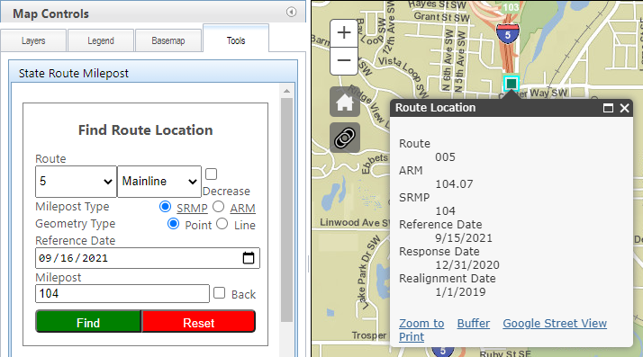
- Find Nearest Route Location – specify a search radius and click on the Find button. Then click on the map to see the nearest State Route and Mile Post.
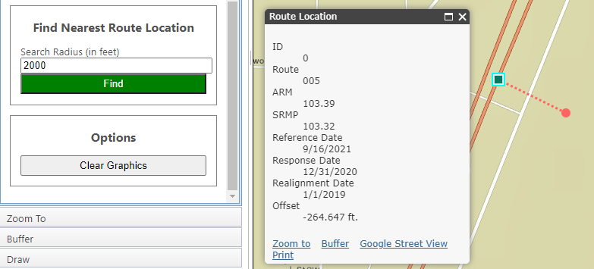
- Clear Graphics – click on the clear graphics button to clear the graphics from map.
- Pop Up Window - gives you a 'Google' and 'Street View' option for Find Route Location and an 'Offset' result value for Find Nearest Route Location.
Zoom To
- Choose from a dropdown list of County, City or Urban Areas in Washington State to zoom to.
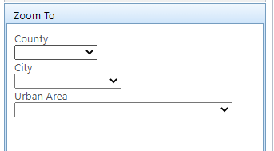
When you select an area to zoom to, the map display will zoom to the selected area, outline the area, and popup a window that displays the name of the area, and provide links to zoom to, Buffer, Google Street View, and Print.
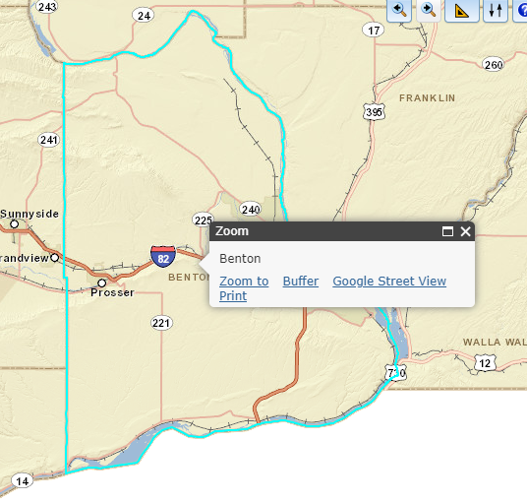
- Clicking on the zoom to link will do nothing, since you have already Zoomed to the area.
- Clicking on the buffer tool will activate the buffer tool in the Map Controls window. (this tool will be described below).
- Clicking on the Google Street View link will open a new browser to the location that you searched for. Since Google Street View images are only available for locations along streets, you may find that your little Google Street View person (Like in the image above), you
Buffer
Draw

Map themes

